Meditation for Children

Learn more about the benefits of meditation for children and download free guided meditations.

What is Meditation?
Meditation is when you focus your mind to help you relax and achieve a mentally clear and emotionally calm state. It is a tool you can use anytime you would like to feel calmer, less stressed, or simply as a daily activity to maintain a good quality of mind.
Meditation is not about turning off your thoughts or stopping your feelings – it’s about observing them without judgement, from a bigger perspective. Learning to meditate is the same as learning any other sport or skill – it can take some time and practice to get better at it, but it can be
a great way to be kinder to ourselves and helps us be kind to others.

6 benefits of meditation

1. Meditation can reduce stress
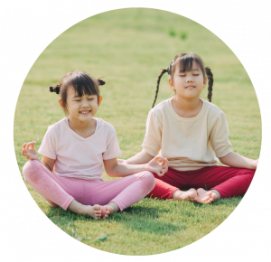
When we feel stressed, our bodies produce a hormone called cortisol, or the ‘stress hormone’. In large quantities, this hormone can be a little harmful for us. Meditation has been shown to significantly reduce our stress levels, helping us to relax.

2. Meditation can help us feel happier
Meditating can help us see ourselves more positively, have a more optimistic outlook on life, let go of negative thoughts, and generally feel happier!

3. Meditation can help us be kinder
Not only does meditation encourage us to be kinder to ourselves, but to other people, too. One study showed that meditation can increase our compassion, and the more people meditate, the kinder they become!

4. Meditation can help us sleep better ​
Meditation has been shown to help us sleep longer as it calms our minds before we go to bed. By relaxing our bodies and releasing tension, we can have a much longer and better-quality sleep.

5. Meditation can help us understand ourselves better
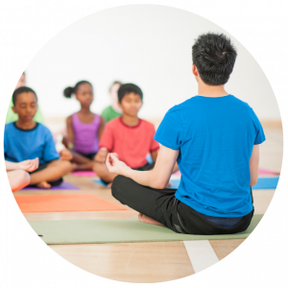
By meditating, we can reflect on ourselves and our experiences. By knowing ourselves, we can see how we relate to people around us. This can help us be more self-assured and confident, as well as improving our relationships with others.

6. Meditation can slow ageing
Researchers at the University of North Carolina found that practicing loving-kindness meditation could slow down biological ageing. They compared people that meditated with people who didn’t, and the DNA of those that meditated indicated a slower ageing process.

52 Lives, 2024
www.schoolofkindness.org

